*Task03 Contextual Inquiry Report*

|  |
| --- |
| **UPMC: eCommerce Initiative**      **Contextual Design Document**     **10/11/2017** |

|  |
| --- |
| **Contextual Design Document**    **NAME** Team 9    **SIGNATURE** Misty Yang, Josie Liu, Yanlin Liang, Jiaqi Wu, Shuoze Wang    **DATE** 10/11/2017 **Reviewed By** |

#### 

# Table of Contents

Topic Page Number

1. Introduction 4

1. Brief description of user: 4
2. Description of Web Sites: 5
3. Description of Tasks 7
4. Account of user observation (transcript): 8

2. Contextual Models 14

1. Flow Model 14
2. Social Model 17
3. Artifact Model 21

3. Summary 28

# Introduction

## Brief description of user

* 1. User A

|  |  |  |  |  |
| --- | --- | --- | --- | --- |
| Name | Age | Web Experience | Reason Selected | User description |
| Expert  User A | 21 | Uses computer everyday for more than 10 hours. | He has little experience in purchasing medicine but is skillful when surfing the Internet and purchasing online. He is the perfect person for us to learn the new young users how to search and choose the right medicine and what portion they value the most. | User A is a 21-year-old master majored in CS. He lives alone and purchase online every 2 days, so he has rich experience in online shopping. But he only purchased medicine once in Amazon and prefers to buy medicine offline, so he is a freshman to online medicine shopping.  He prefers offline pharmacy because of convenience. Price and rating matter to him when choosing medicines, so he always compares and get the best one. He cares about what his mother would like him to buy. When doing online shopping, he prefers checkout as a guest. |

* 1. User B

|  |  |  |  |  |
| --- | --- | --- | --- | --- |
| Name | Age | Web Experience | Reason Selected | User description |
| Novice User B | 52 | Uses computer everyday. | She has very limited experience in buying medicine online and she has general knowledge of the computer and website. In addition to this, she has a lot of medical knowledge and works in the hospital for 10 years. So she would evaluate the website more thoroughly. | User B is a 52-year-old housekeeper in Pittsburgh. She lives alone and purchases the medicine every two months offline. In addition to this, she has lots of knowledge of medicine and likes looking up the price online through GoodFx before going to stores. So she is a new one to online purchasing medicine who has a lot of knowledge.  When choosing medicines, she prefers medicines that used before and with a good brand. She prefers to check out as a guest while buying medicines online.  She usually chooses offline pharmacy stores because it’s more convenient and quicker. |

## Description of Web Sites

* 1. CVS Pharmacy(www.cvs.com)

According to the survey, CVS.com attracted at least 26 million visitors annually by 2008. The huge unique views make CVS one of the biggest online pharmacy retail websites. Most importantly, CVS.com and UPMC both take the leading position in their industry, which makes CVS.com a potential opponent to UPMC Pharmacy in the future. Also, CVS.com is similar to UPMC Pharmacy for their technical support, they both have an outstanding development team and are able to design the most user-friendly websites. As for the difference, CVS.com has much more categories and types of merchandise than UPMC Pharmacy, include Beauty, Photos and Skin Care. It would be beneficial for UPMC pharmacy to learn CVS’s searching optimization techniques.

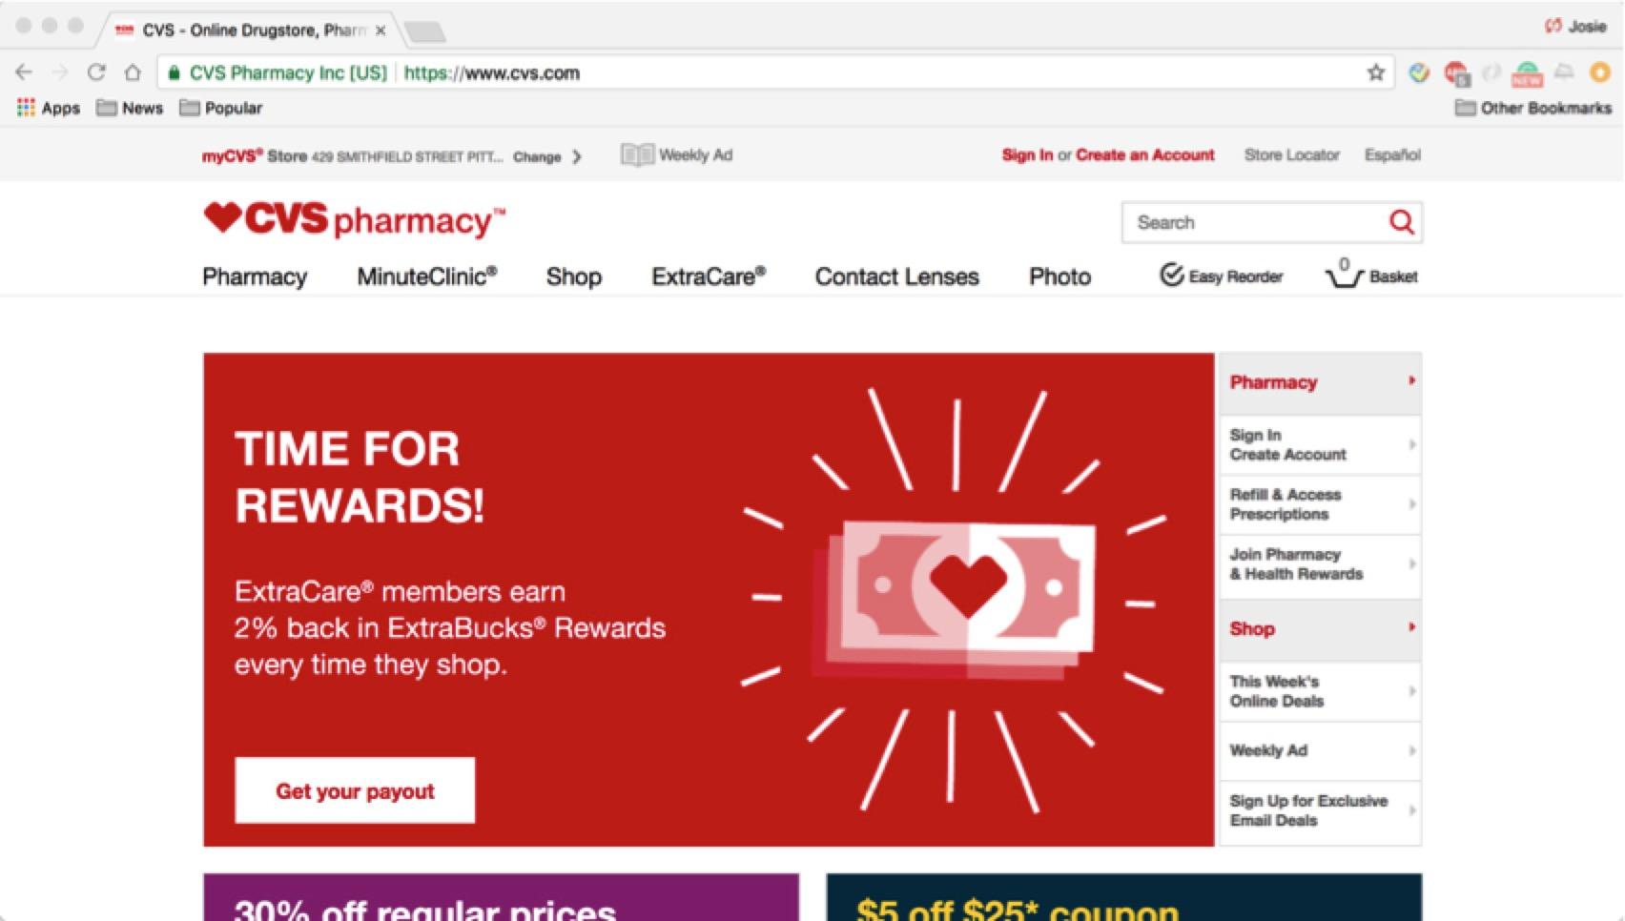

* 1. Canadian Pharmacy World(www.canadianpharmacyworld.com)

Canada Pharmacy Online is one of the reliable sources of International prescription drugs who also has over 10-year history. In this website, patients can order RX or OTC, which is similar to the UPMC pharmacy. This website is aimed at customers in the nearby community, which is similar to UPMC, community-oriented hospitals and pharmacy stores. Besides, as for the difference between UPMC and the Canadian Pharmacy World, UPMC Pharmacy ’s total audience is bigger and has more strong technical support than the Canadian Pharmacy World. UPMC pharmacy can learn a lot from the Canadian Pharmacy World’s awful design and search system.

This pharmacy website has several obvious problems like Category isn’t showed on the top front page and it’s hard for the customers to find the category; the product’s detail page doesn’t show the product’s photo; Customers can not select filter OTC or RX by the filter.

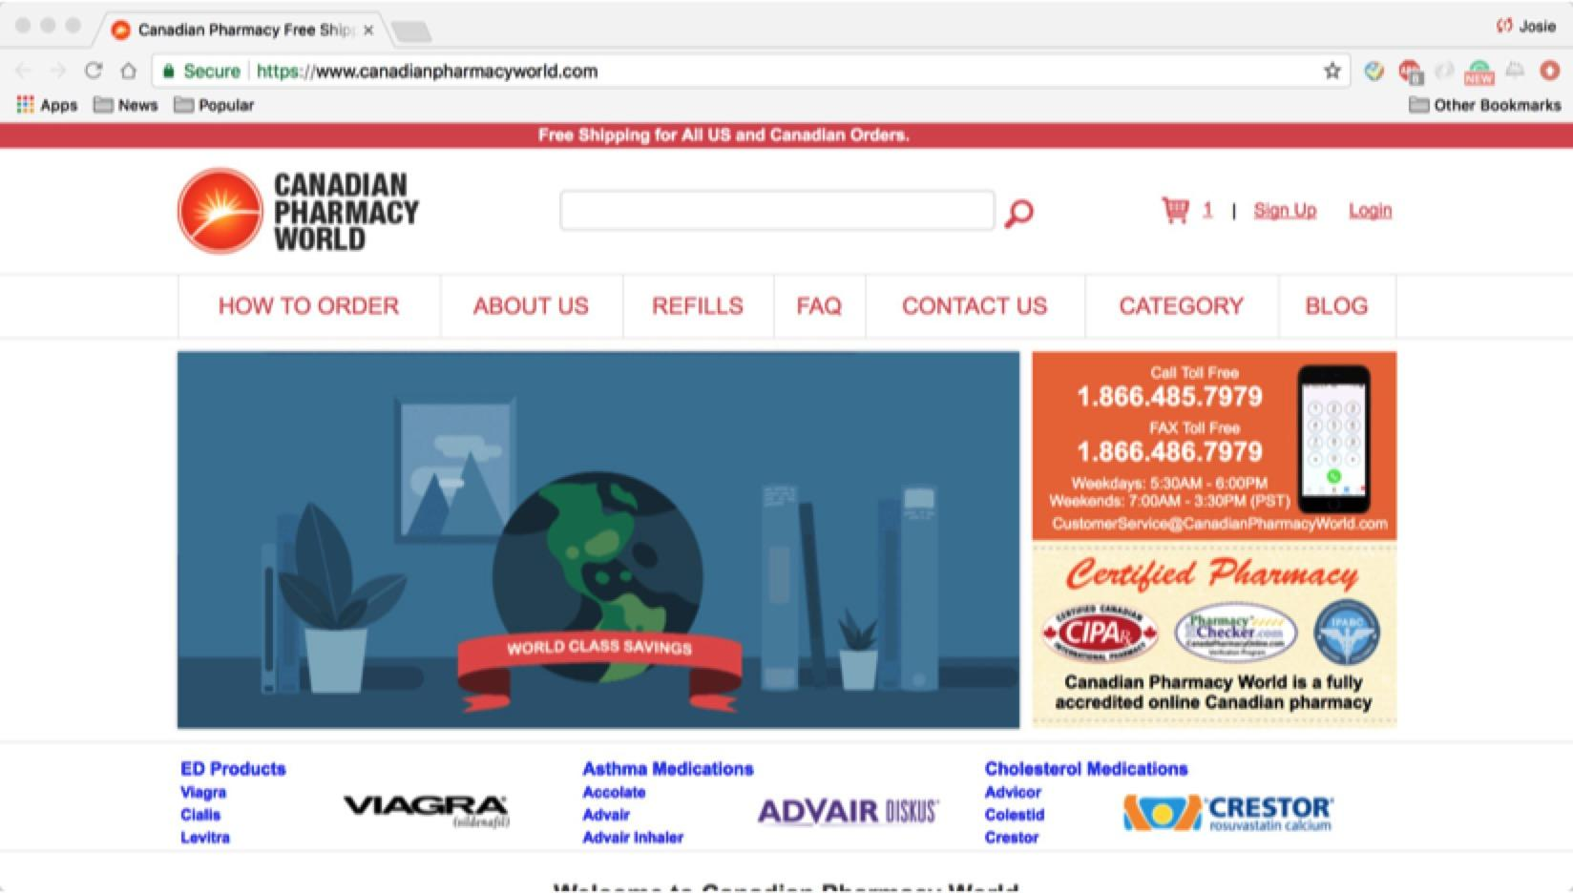

## C. Description of Tasks

**Questionnaire**: Users should fill out a short survey before conducting tasks.

* What is your age?
* What is your Occupation?
* What is your educational level?
* Do you live alone or whom do you live with?
* How do you decide what medicine you need to buy?
* How often do you use the computer?
* How often do you do online shopping?
* How often do you buy medicine?
* Do you prefer offline when buying medicine?
* What offline stores do you usually to buy medicine?
* What online websites do you usually use to buy medicine?
* What is the rate do you buy medicine by online shopping verses by going to a medicine store?
* What is your favorite online pharmacy store? (if any)

**Tasks**: During the tasks, users should try to finish these tasks under our instructions.

Situation: Assume that you are having a headache. Given the fact that you are suffering from chronic gastric ulcer, try to buy some medicine(s) through the websites.

Task 1: Find

* Find the medicine you want to buy.
* Try a different way to find the medicine [search bar / category browsing]

Task 2: Buy

* Compare the results you just searched for and choose one medicine you want to buy.
* Explain why you are going to buy this medicine with justification.
* Check out the medicine you are going to buy
* (If registration needed) Could you check out without creating a new account?
* Provide a fake shipping address and payment method and do exactly what you would do when you are actually buying the medicine.

**Feedback**: After the user finishes the tasks, the following question will be asked:

* Do you think the descriptions of medicine are clear on this website?
* Do you think you get sufficient help/information from the website?
* During the task, what parts of the website design made you confused, and what steps do you think were inefficient?
* During the task, what parts of the website design make the process more efficiently?
* How do you like this interview? Is there any improvement for the interview?
* Are you willing to be contacted for further information?

## Account of user observation (transcript)

**User 1**

1. Q: What is your age?
2. A: 21.
3. Q: What is your Occupation?
4. A: I am a CMU full time master student.
5. Q: Do you live alone or whom do you live with?
6. A: I live alone.
7. Q: How do you decide what medicine you need to buy?
8. A: I usually call my mom can say hey I have such symptom, what medicine should I choose?
9. Q: How often do you use the computer?
10. A: Probably 10 hours a day.
11. Q: How often do you do online shopping?
12. A: Every week.
13. Q: How often do you buy medicine?
14. A: Whenever I am sick. A month maybe?
15. Q: Do you prefer offline when buying medicine?
16. A: Yes. I prefer buy medicines over the counter, it is convenient for me.
17. Q: What offline store do you usually use to buy medicine?
18. A: CVS and Walgreen.
19. Q: What online website do you usually use to buy medicine?
20. A: I never use online pharmacy stores.
21. Q: Now we are going to test the **first website, Canadian Pharmacy World**. Please try to find the medicine for a headache from this website.
22. A: So I have a headache and gastric ulcer. I want to use the search bar.
23. [Search result page shows “Sorry, we did not find any result for your search headache.”]
24. A: What? Why no result for a headache? I don’t think there is no medicine for a headache, it might just because they have a very poor developed searching function. I want to use the category.
25. [The user clicks category, uses ctrl+f to search the keyword “headache” in category page].
26. A: Ok. They don’t have the keyword here neither.
27. Q: What are you looking for now?
28. A: There are so many categories here and there are in alphabetical order. I am not sure which specific category I am looking for so I am just going to go through each category until I find the right one that may have headache medicines.
29. [The user uses Google to see the meaning of some terms in category]
30. A: Ha! I see “Pain Medications”. It must be it.
31. Q: So how do you decide which to buy?
32. A: Just check one by one I think, since there's not so much information I can see on the result page.
33. [The user clicks every OTC medicine under the pain category]
34. Q: What are you looking for?
35. A: I am trying to figure out if there are any side effects for my stomach. It doesn’t seem to have enough description.
36. Q: How would you know if there’s side effect? What are you looking for?
37. A: The medicine’s warning, which I don’t see any.
38. [The user searches “headache with stomach ulcer buy which medicine” in Google, read the article “Best headache medicine for stomach” and find a medicine called Tylenol]
39. Q: What are you going to do?
40. A: Now I know the medicine name, I can just simply search.
41. [The user uses ctrl+F to search “Tylenol” on the result page under “Pain Medications” and find it]
42. A: Now there are three of them. I guess the only difference is dosage.
43. Q: How do you decide which one?
44. A: I think I need to compare their prices. Price is important.
45. [The users clicks on “check price” on the first one and it navigates to a new page]
46. A: Why it goes to a new page? It says ”check price”, why it doesn’t just simply show the price in the area of this button?
47. Q: Why?
48. A: Because then I can compare them on the same page, it’s more efficient. Now I have to go to each medicine description and remember the price and go back and click on another one. It’s killing me.
49. [After comparing]
50. A: I will choose the one with lowest unit price.
51. Q: Now you can buy it.
52. A: Ok. So add to cart, checkout.
53. [The page says “login” and “become a new member”]
54. A: I obviously don’t have an account, but I don’t want to register. It would be better if I can checkout as a guest, you know? Just provide my address and payment.
55. [Then the user chooses to become a member, creates an account, logs in and fill the payment method successfully.]
56. Q: Now let’s test the **second website, CVS Pharmacy**.
57. Q: What are you looking for?
58. A: Some medicine for my headache.
59. [The user chose the “Pain & Fever” button in the “Category” column and got 641 results]
60. A: 641? Is it an error message? Oh no it’s the results number.
61. Q: Why you thought it’s the error message?
62. A: The text is huge, and I don’t see any results at first glance. I thought it would be some medicine pictures, and 641 sounds like an error message like 404.
63. [After looking at the category for a while]
64. A: Ok, it is wasting time. I am going to use the search bar.
65. [The user searches for “Headache”]
66. A: There are lots of results, let me find out the best one.
67. Q: What would you do next?
68. A: I have to examine the side effect for each medicine. This medicine might cause stomach ulcers, so I can’t buy it.
69. [The user checks another medicine, finds warnings]
70. The description is very clear for me. This might also cause stomach ulcers, I cannot use this.
71. [The user carefully read another medicine named Be Koool gel]
72. A: This will not cause side effect about my stomach, I think it’s fine.
73. Q: Are you taking this one?
74. [The user browsing another medicine]
75. A: Wait a minute, let me find some other medicine suitable for me. I always compare and pick the best.
76. Q: How do you make a choice?
77. [The user found another medicine that will not cause stomach problem]
78. A: I care about ratings. Let me see, this medicine has a 3.5 rating and that gel has a 5 rating, so I’ll take the gel. Also “Gel” is something my mom would like me to buy I think, it sounds safe.
79. Q: Ok now can you find this medicine without using the search bar?
80. A: Then I need to use the category navigation.
81. [Clicks on “Shop”, looks at the “shop by category” section, and clicks “Health & Medicine”]
82. Q: What are you looking for?
83. A: So this is so overwhelming. It gives to me all the medicine. Here suppose to have more sub-categories.
84. A: Oh hey there they are. There are on the different position that before. This is not clear enough.
85. [Clicks on “Pain & Fever”]
86. A: Again the “Browsing all products: 638 results” message is so big and it looks like an error message.
87. A: Here are some more sub-categories, but there are on the middle part of the page again. First they are in the center of the page, then they move to the side, now they are here again.
88. Q: Do you think it’s inefficient?
89. A: Of course, and kind of confusing.
90. Q: What are you looking for?
91. A: I remember the category of the medicine I just chose is Migraine Relief under Pain & Fever.
92. [Clicks on Migraine Relief and finds the same medicine]
93. Q: Now would you please try to buy it?
94. [Clicks add to basket and checkout]
95. A: I can continue as a guest. I think it’s fine, I don’t need to sign up, it’s convenient.
96. [Types in the email address and go through the payment page]

**User 2**

1. Q: What is your age?
2. A: 52.
3. Q: What is your occupation?
4. A: Housekeeper.
5. Q: What is your education level?
6. A: High school.
7. Q: Do you live alone or you are living with your family?
8. A: Live alone.
9. Q: How do you choose what kind of medicine to buy?
10. A: I usually choose the medicine I used before. And I have many prescripts to refer to.
11. Q: So how often do you use a computer?
12. A: Every day.
13. Q: How often do you use online shopping?
14. A: I purchase online every week.
15. Q: How often do you buy medicine？
16. A: Every two months.
17. Q: Do you like purchasing medicine in store or online?
18. A: In the store. Like Rite Aid.
19. Q: So you don’t use the internet to buy medicine?
20. A: I would look up the price on the website and go to buy medicine in the store.
21. Q: Which website do you like to look up the price?
22. A: GoodRx to find the price.
23. Q: Let’s look at the first website. So what medicine will you buy when you have a headache and a gastric ulcer?**[CVS]**
24. A: I want to click the pharmacy.
25. [The user clicks the “Pharmacy”. And then clicks the “Drug Information Center”.]
26. [Looks at the screen for 20 seconds.]I don’t know where to find it.
27. Q: Well maybe you can use the “Shop”.
28. [Clicks the “Shop” and scrolls down and clicks the “Digestive Health”.]
29. A: I am going to choose this.
30. [Clicks the “Antacid”]
31. A: I find the wrong place.
32. [Back to “Health and Medicine” and Scrolls down and up and then clicks the “Categories”. Then she chooses the “Pain & Fever” and clicks the “Migraine Relief” after that. She looks up and down and chooses one kind of medicine.]
33. Q: Why you choose this medicine?
34. A: First, it is because of its price. And it has the CVS brand. I am trying to figure out it interacted with my ulcer.
35. [Scrolls down and checks the ingredients and Details of this medicine.]
36. A: So it has a problem. It has aspirin. I won’t choose this one.
37. [Goes back to the last page and chooses another kind of medicine.]
38. A: This kind of medicine also can not work. It has aspirin which will lead to ulcer.
39. Q: Do you have experience about the ulcer?
40. A : I have worked in hospital for 14 years.
41. Q: So you don’t want to choose this?
42. A: Yes, I want to go back and find some medicine without aspirin.
43. [Goes back and looks several kinds of medicine and chooses one kind of medicine “Advil Migraine Capsule”.]
44. Q: Why do you choose this one?
45. A: Because the Advil usually does not have aspirin.
46. Q: So you know this brand well?
47. A: Generally. It has no aspirin. I may choose this one because it has no aspirin. Although it has the warning for stomachs. But generally migraine medicines have this warning.I am going to choose this one as long as it does not have aspirin.
48. Q: Ok, now, you should buy it.
49. A: I would add it to the bucket and check it out.
50. [When checking out, it has a login label]
51. Q: What will you do next?
52. [Clicks the sign up and a lot of information should be filled.]
53. A: Oh, is it must sign up?
54. A: I’d better check out as guest. Oh here it is, didn’t see it before.
55. [Clicks on check out as a guest]
56. See? It is why I prefer offline. It needs 2 days shipping, buying in a store would be quicker.
57. Q: So, now, you should find the same medicine without categories.
58. A: So I’d like to use search bar with “headache relief”.(The website shows 260 results.)
59. [Scrolls down and choose one kind of medicine]
60. Q: Why do you choose this one?
61. A: Because it has no aspirin in there. I want to buy this one.
62. [Open the second website “**Canadian Pharmacy World**”]
63. Q: So now you are going to do the same procedures on this website.
64. [Try to find “headache” in “Category”, but not found]
65. A: They don’t have headache in their category, aweful!
66. Q: So now you have to use the “search” bar.
67. [type “headache” in the search bar] and nothing is found.
68. A: I’ll try to search the name of medicine.
69. [Fills the “EXCEDRIN” in the search bar] and nothing is found.
70. A: I am sure they have this kind of medication, but I think the reason would be they put different names for search.
71. A: I am going to FAQ.
72. [Clicks the FAQ and scrolls down]
73. A: Ok stop! This is not going to tell what should I do. I am trying to find the way but I couldn’t.
74. [She refills the “Tylenol” in the blank and choose the second kind of medicine]
75. Q: Why do you choose this one?
76. A: Because it is the first medicine I found yet. I am enough with it.
77. Q: Then you should check out.
78. [She clicks the add cart and check the medicine out]
79. A: It definitely would be better if I can check out as a guest, like CVS.
80. Q: What do you think of the payment page?
81. A: I think it is fine enough.
82. Q: What do you think of this Canadian website?
83. A: The letters are too small. And the font is not big enough. I mean the font is not bold. I don’t like this kind of style. And the menus are too small to use. And the medicine categories are positioned randomly. I have no idea how to choose.
84. Q: Which website do you think is better?
85. A: I think it is CVS. I can’t find the medicine I want in this Canadian website.
86. Q: What are their advantages and disadvantages?
87. A: I think CVS has a more clear category and it has a lot of pictures that help me a lot.

And it has a lot categories and many specific items. And Canadian Pharmacy is pretty

bad. I can not find anything I need and it’s disgusting. It will help a lot if the Canadian

Pharmacy could add more pictures in website so that it would be more easy to

recognize.

# 2. Contextual Models

## Social Model

The social model is mainly about thought process, mind-sets, feelings, and attitudes of the user, which often have the significant influence on the way that a user chooses to do the work.

In this case, our user is a 21-year-old master student, who is an experienced computer user that usually spends a lot of time dealing with websites. During the test, we kept asking for his opinions and reasons to make certain moves, which gives us a lot of information about his thoughts that help us build this social model.

**Expert User A**

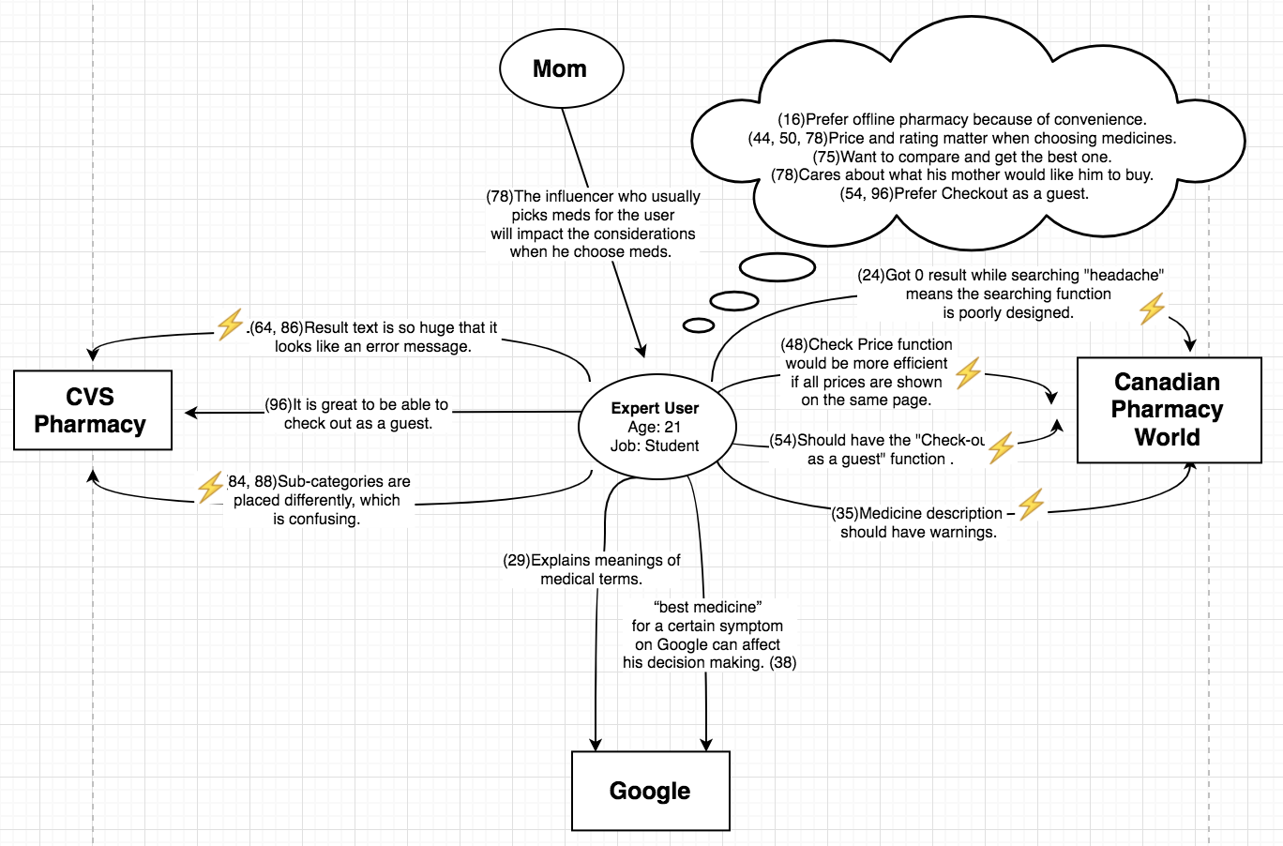

**Novice User B**

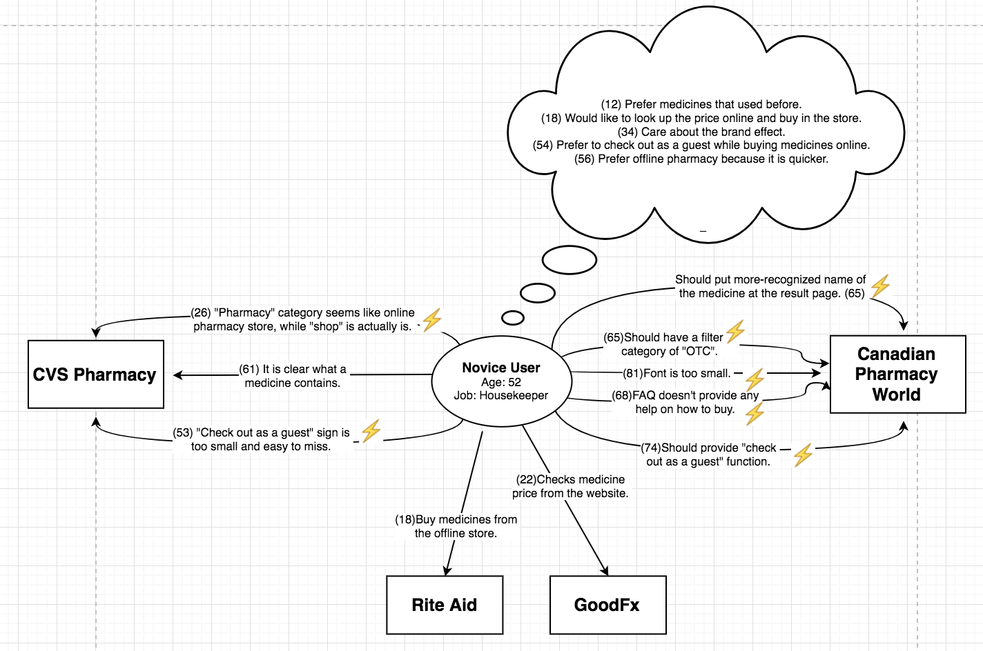

## Flow Model

**Expert User A, Canadian Pharmacy World**

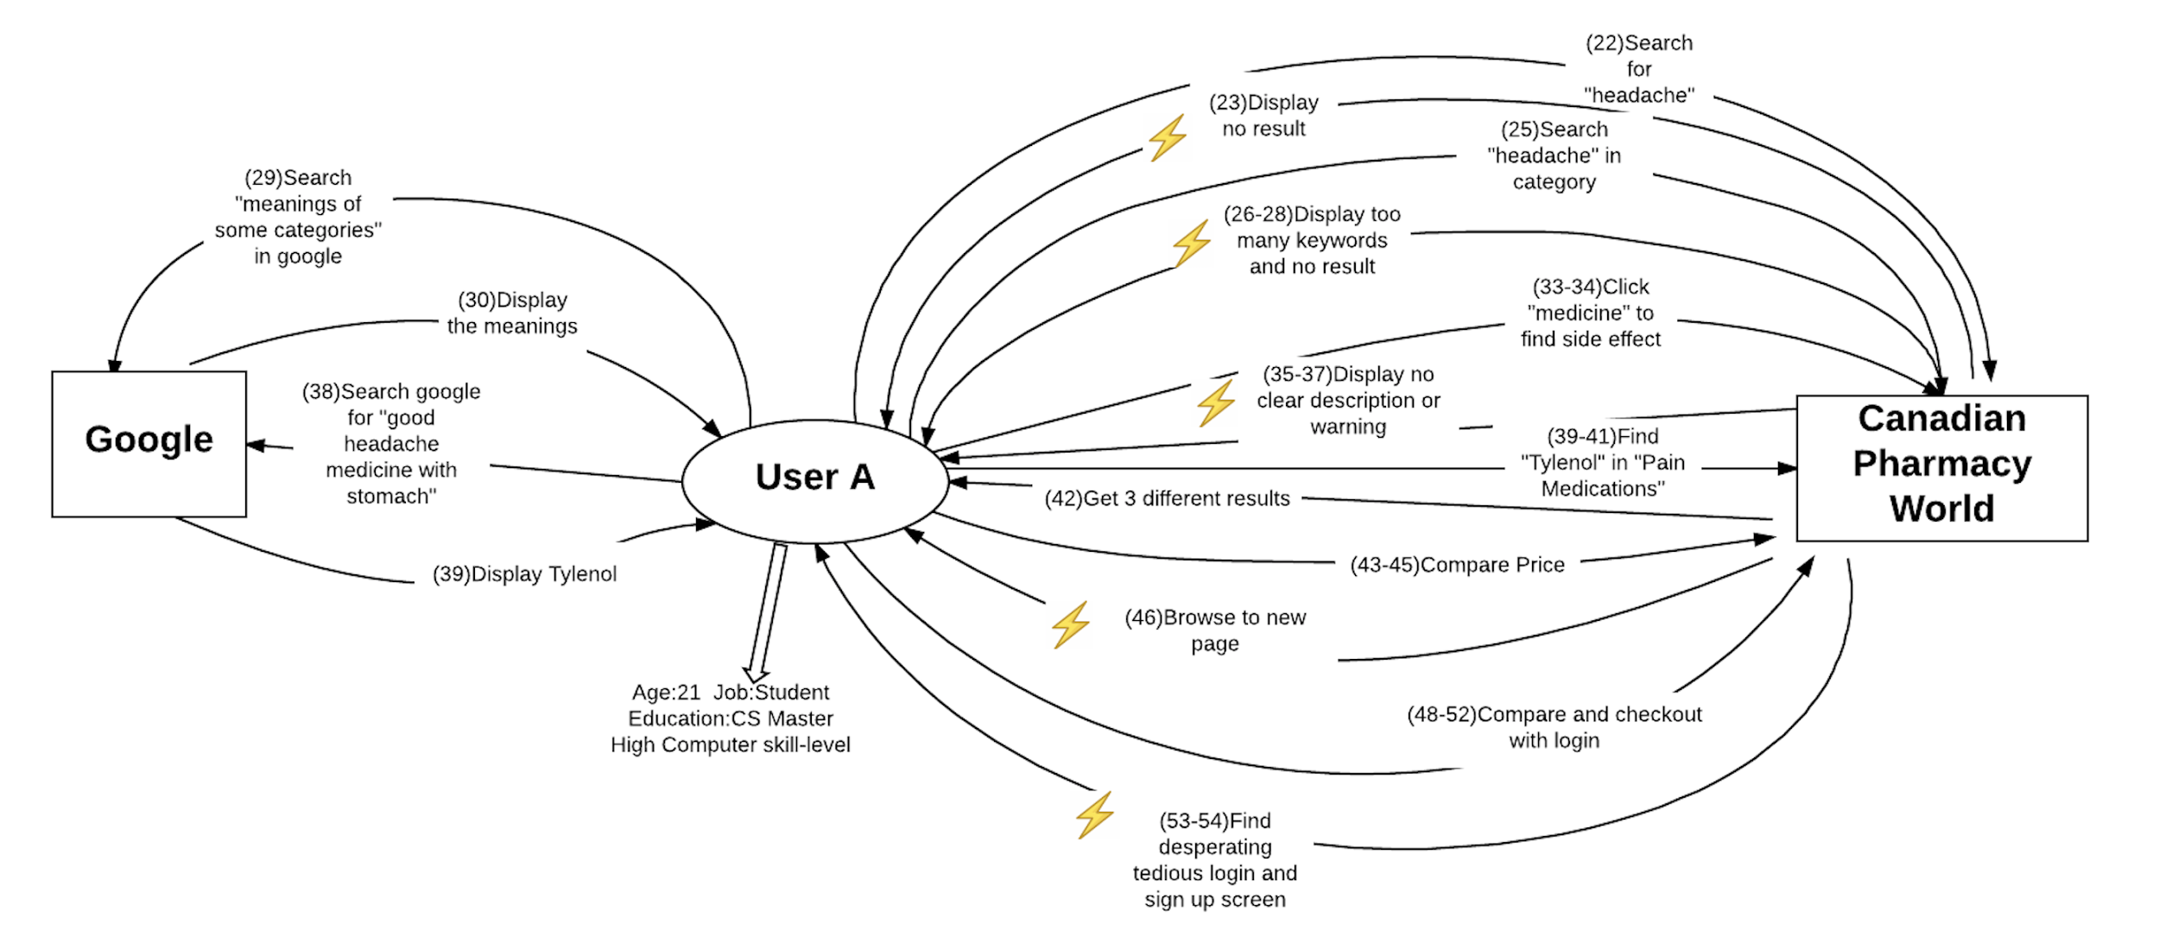

In the first flow model of the participant A. 5 breakdowns, all user’s feelings about the websites and behaviors are recorded. As for the participant, the younger one has much experience about purchasing medicine online. He has no problem reading the ingredients and warning and he is a master student in CMU SCS. And he is familiar with how to search keyword in the shopping website and check out. For the first website - Canadian Pharmacy World, it is not friendly to him when he wants something. Anyway, the total evaluation to this website from him is bad.

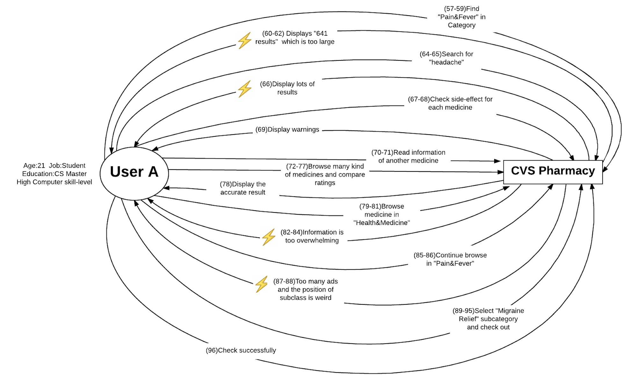

In the second flow model of the first participant, 4 breakdowns are recorded. The user A, a young user with little exposure to Internet and online shopping, found it somehow easy to visit this website, since the category is useful and easy to find what he wants.

**Novice User B, CVS Website**

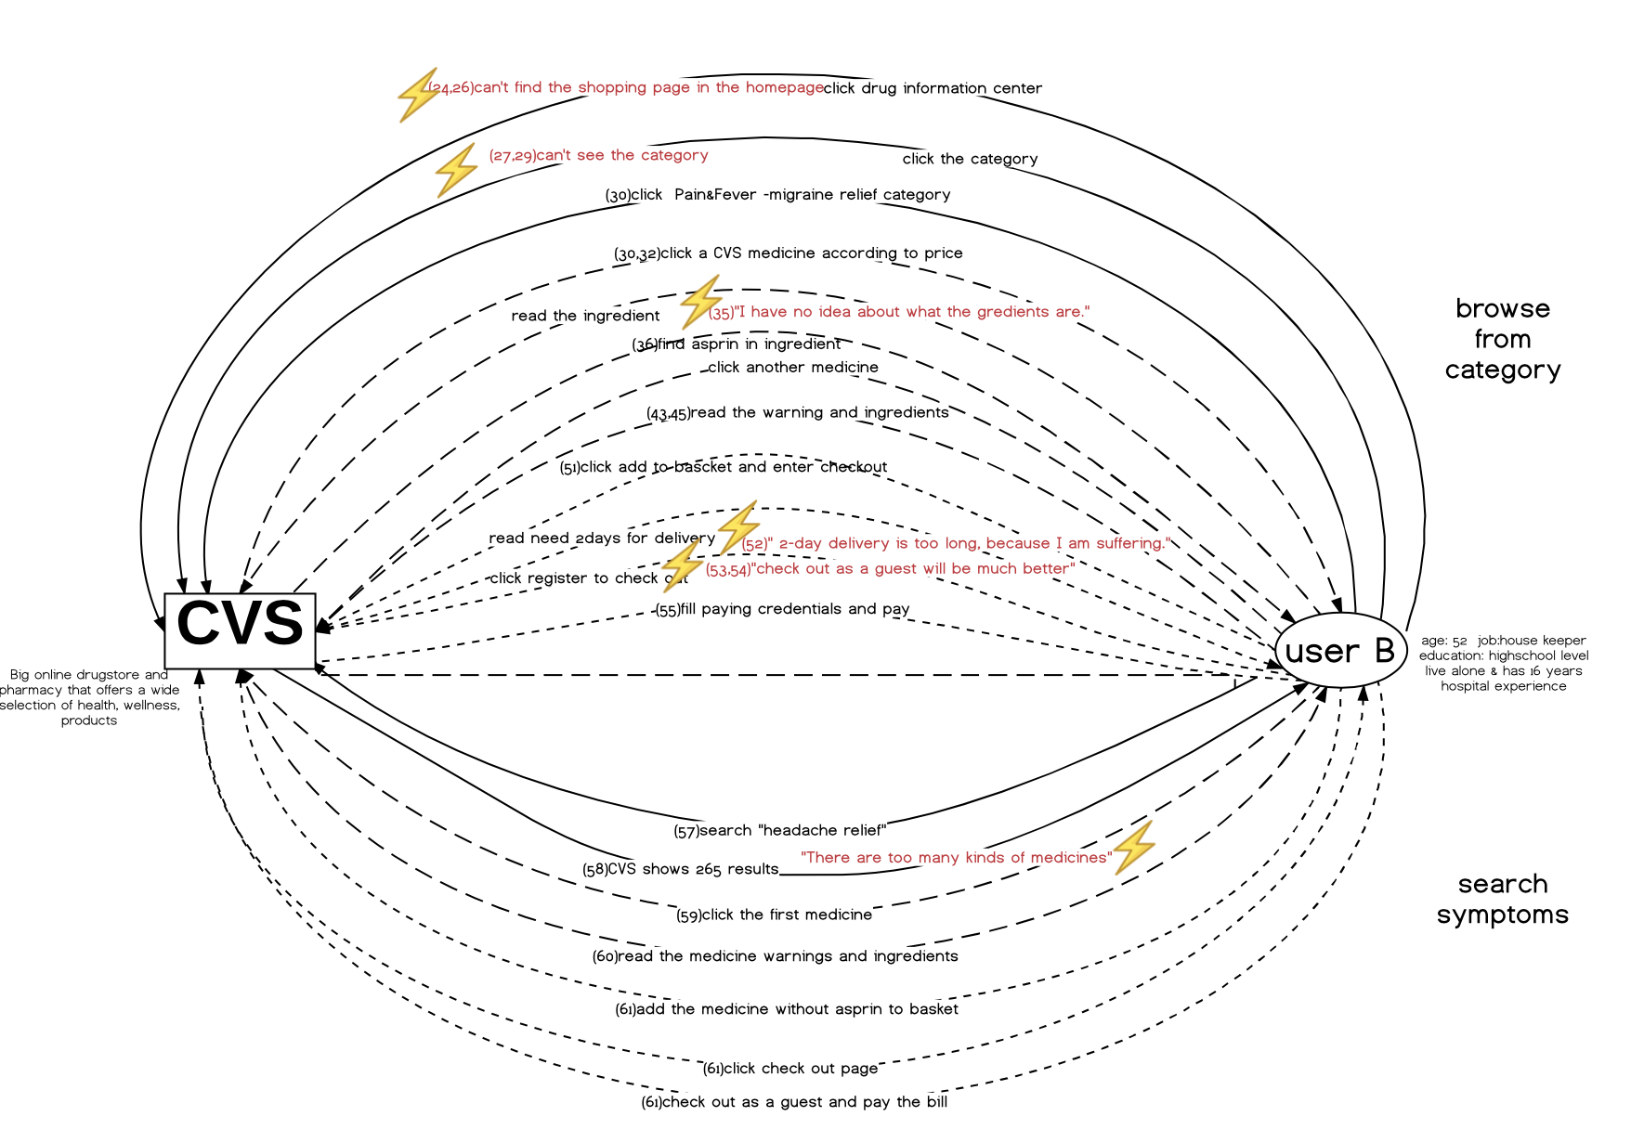

In the first flow model of the participant B. 6 breakdowns, all user’s feelings about the websites and behaviors are recorded. As for the participant, the older one has little experience with purchasing medicine online. She has no problem reading the ingredients and warning because she has worked in the hospital for more than 14 years. And she is familiar with how to search keyword in the shopping website and check out, but she is not familiar with search medicine using category. For the first website - CVS, it’s not easy for her to find the shopping page and she also has a hard time reading the category because the fonts are too small for her to read. Also, she is not familiar with searching using sorting.

**Novice User B, Canadian Pharmacy World**

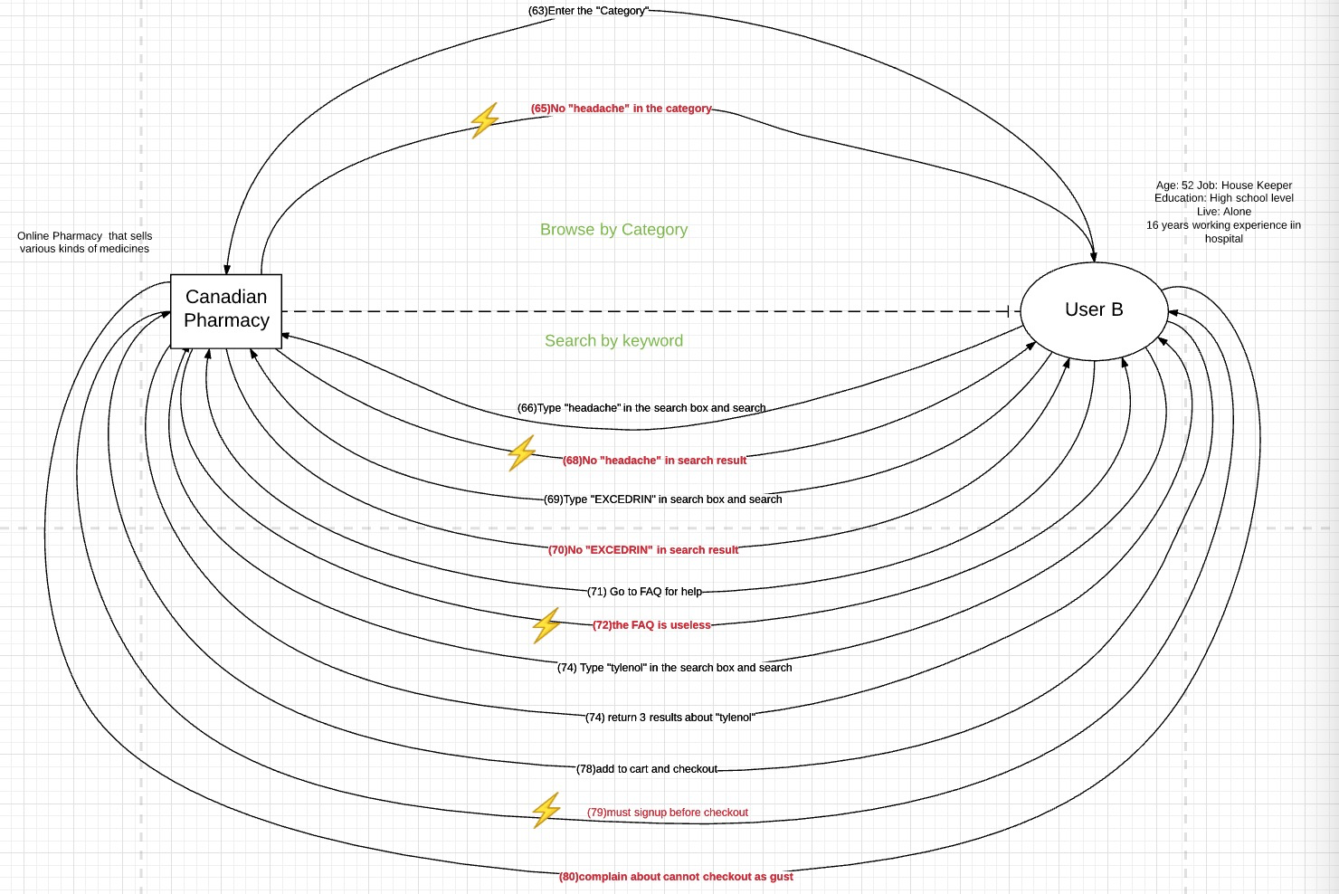

In the second flow model of the second participant, 4 breakdowns are recorded. The user B, an aged user with little exposure to Internet and online shopping, found it hard to use the Canadian Pharmacy, since the category is useless, and the website had no picture for each medicine, so she can hardly build up any relationship between the medicine shown on website and the medicine she used to take. Although she is familiar with how to search keyword in the shopping website and check out, she still found it hard to get what she wants. Besides, she also found the FAQ totally useless.

## 

## 

## Artifact Model

**Expert User A, CVS Website**

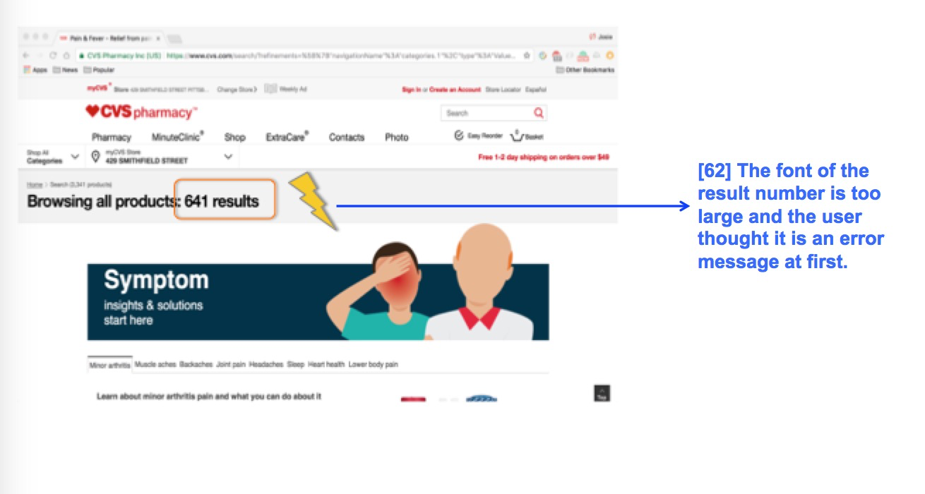

Result page

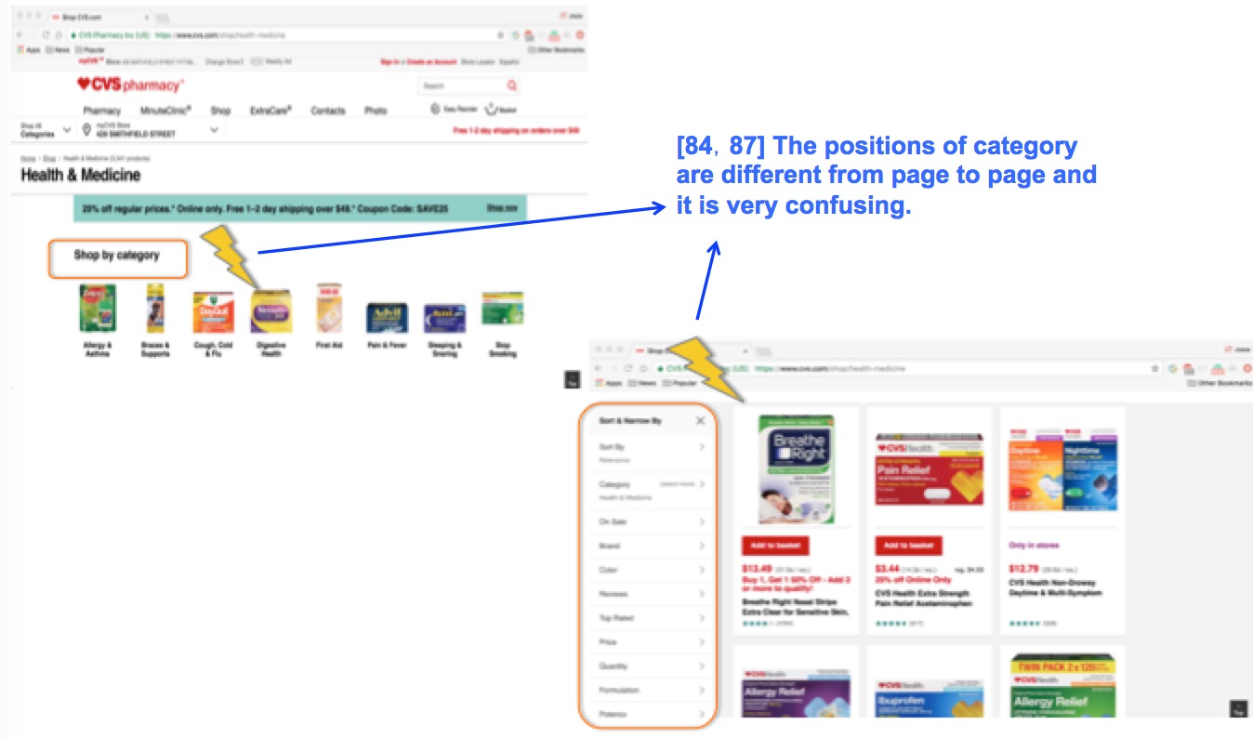

Result page

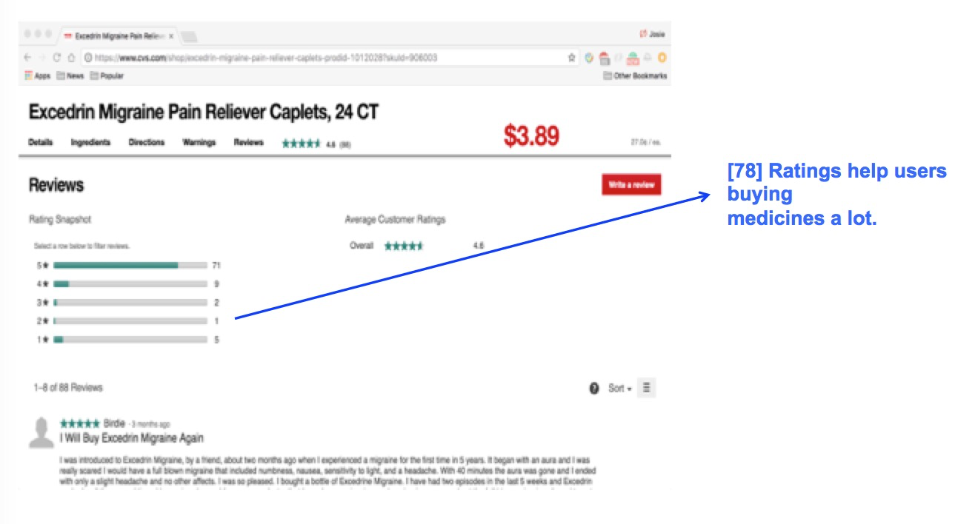

Medication page

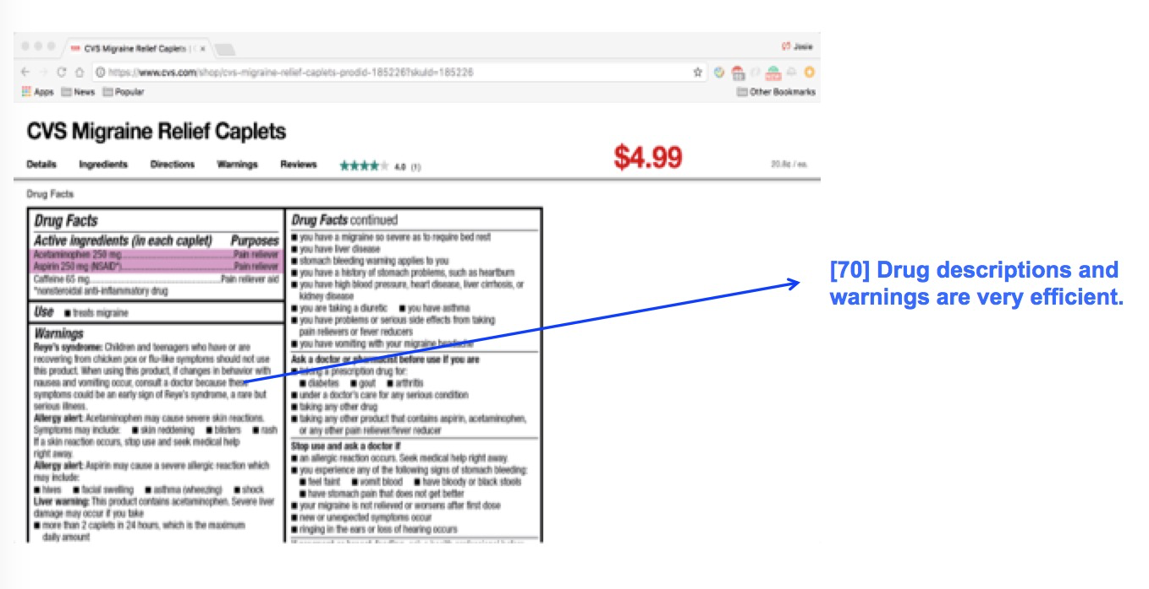

Medication page

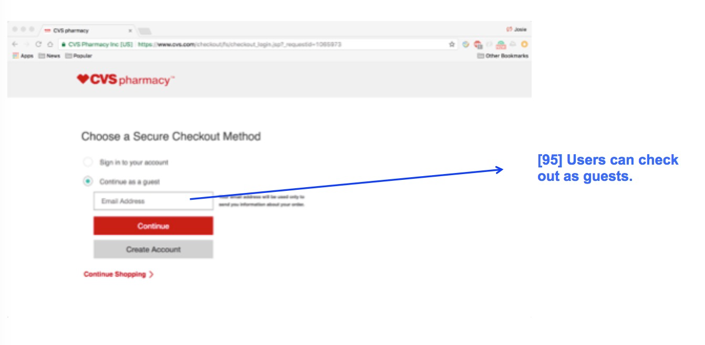

Checkout page

**Expert User A, Canadian Pharmacy World**

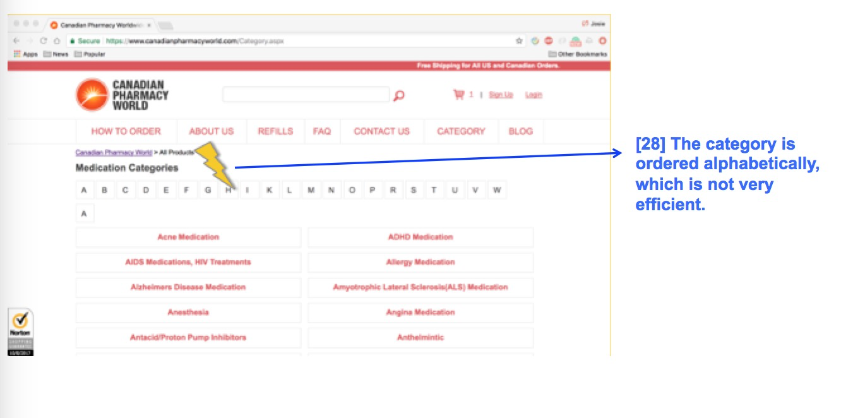

Category page

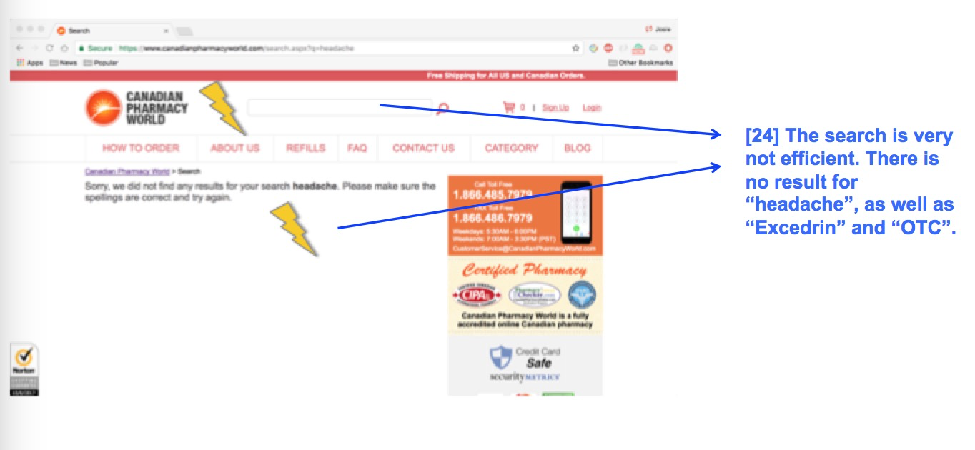

Search result page

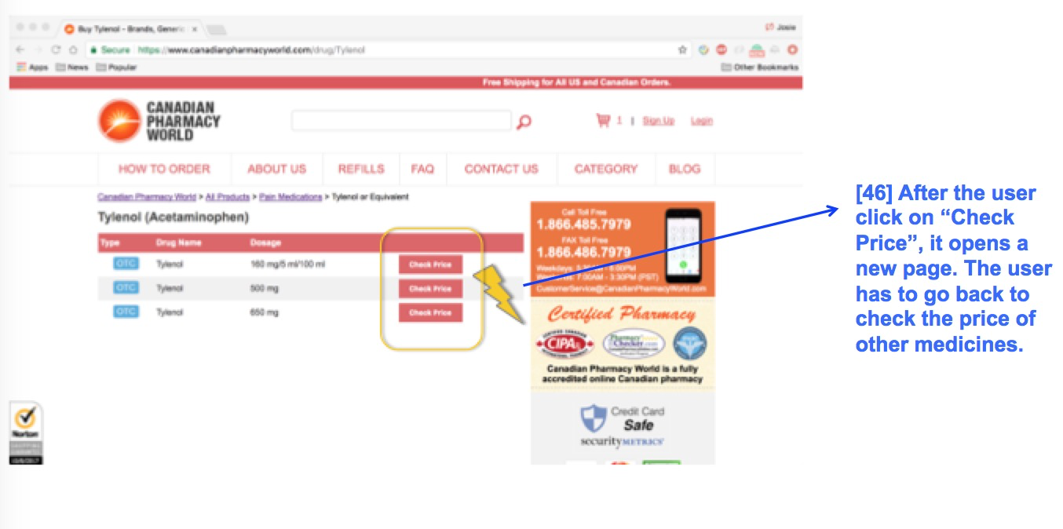

Search result page

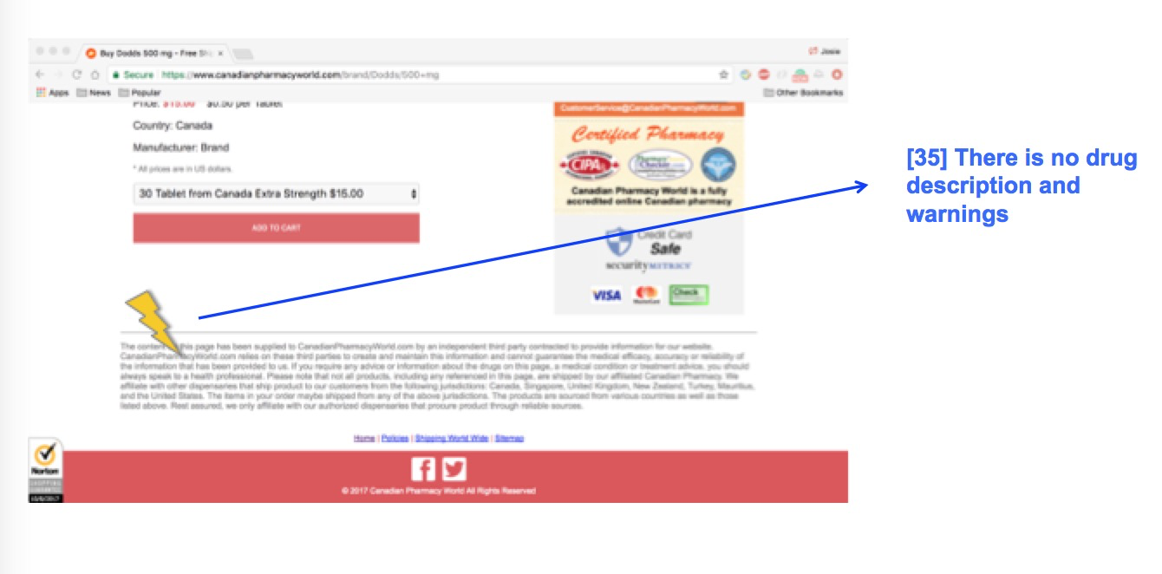

Medication page

**Novice User B, CVS Website**

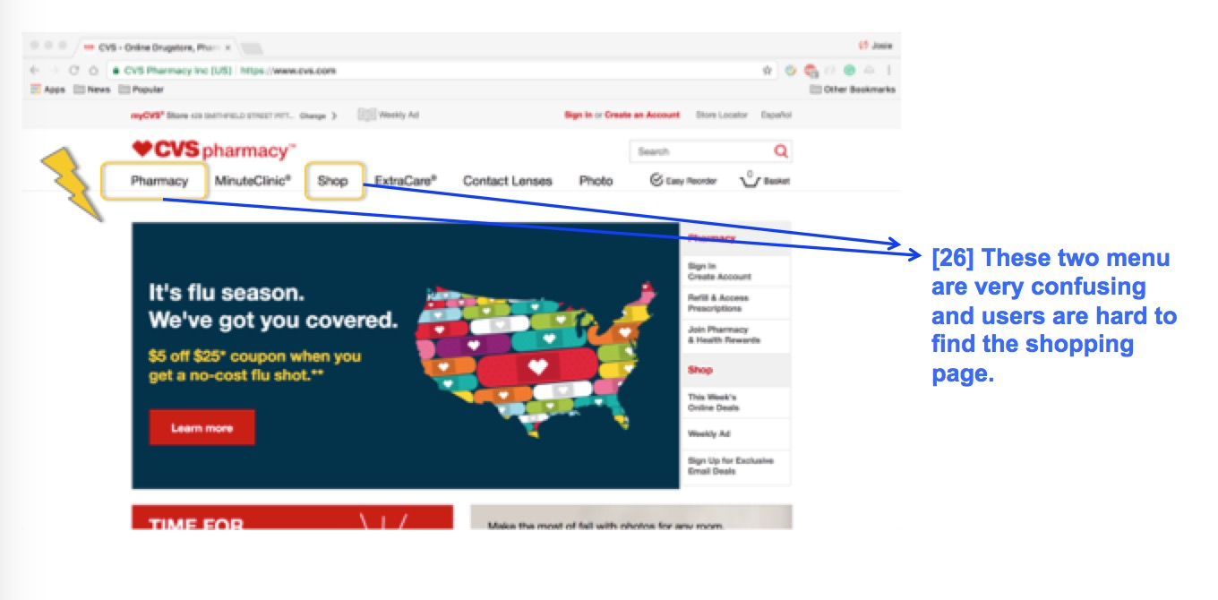

Home page

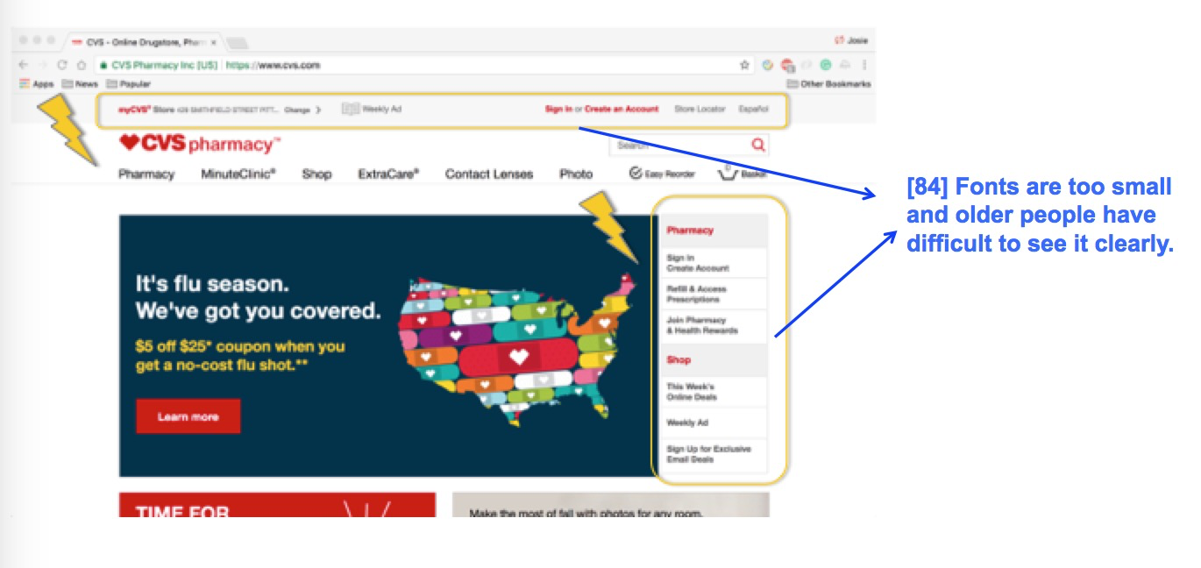

Home page

**Novice User B, Canadian Pharmacy World**

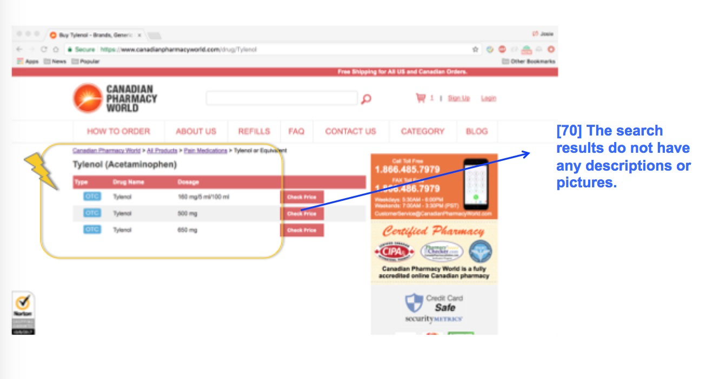

Search result page

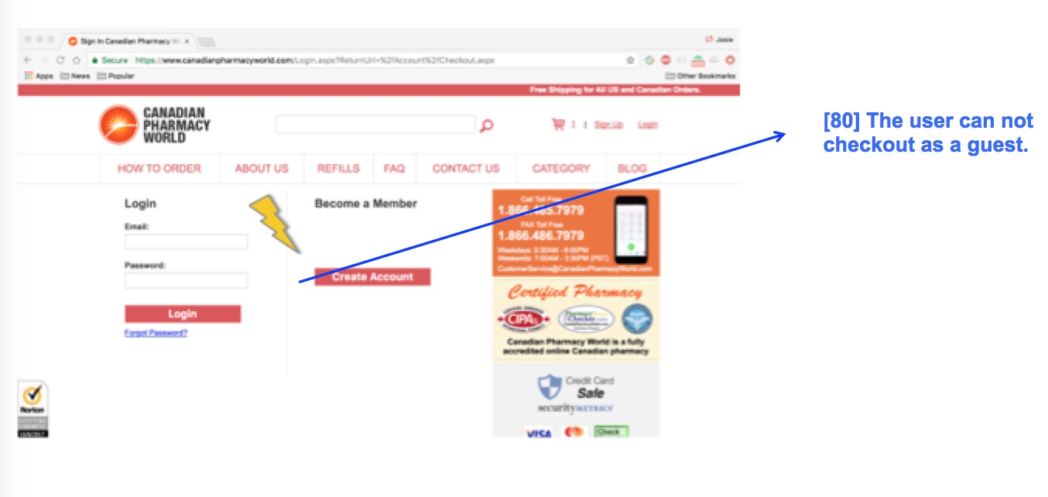

Checkout page

# **3. Summary**

What we should do:

1. Drug descriptions(eg. Side effects/ ingredients/warnings): The users can get more information when they are buying drugs. It can also be dangerous if the users do not know about any side effects.
2. Ratings: This will help people to decide whether to buy this drug or not.
3. Check out as guests: It is very convenient for users to buy drugs.
4. Search function efficiency: Users can search by symptom, the name of drugs or categories. By doing this, users can always find results.
5. Descriptions and pictures of search results: It is very helpful for the user to choose products.

What we should not do:

1. Fonts cannot be too small: Older people usually had bad eyesight.
2. Fonts of search result number cannot be too large: It is very confusing and the expert users may regard the number of search result an error message.
3. Consistent category display: The position of categories should be consistent from page to page since it is very hard for the user to find them.
4. Alphabetical category cannot be used: It is very inefficient and confusing for users.